- Funkcje językowe – wymień i opisz.
…………………………………………………………………………………………………………………………………………………………………………………………………………………………………………………………………………………………………………………………………………………………………………………………………………………………………………………………………………………………………………………………………………………………………………………………………………………………………………………………………………………………………………………………………………………………………………………………………………………………………………………………………………………………………………………………………………………………………………………………………………………………………………………………………………………………………………………………………………………………………………………………………………………………………………………………………………………………………………………………………………………………………………………………………………………………………………………………………………………………………………………………………………………………………………………………………………………………………………………………

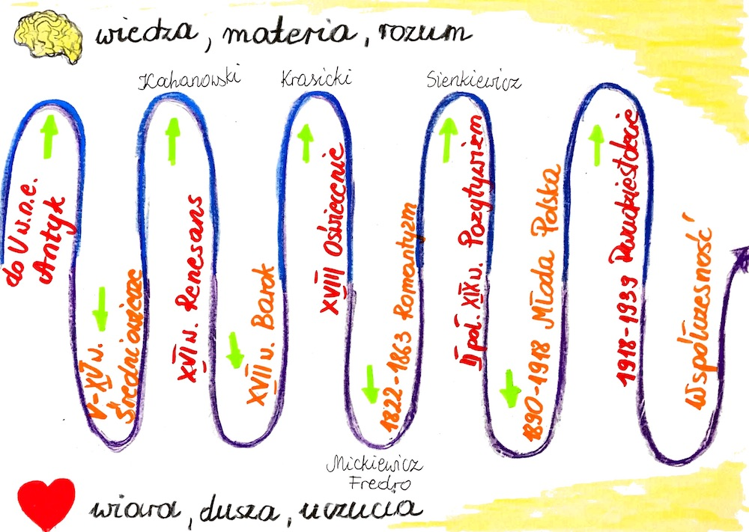

Porównaj poznane dotąd epoki literackie. Uwzględnij poniższe kategorie:
1. czas trwania
2. filozofia
3. twórcy i dzieła
4.gatunki literackie, nurty, style, motywy
………………………………………………………………………………………………………………………………………………………………………………………………………………………………………………………………………………………………………………………………………………………………………………………………………………………………………………………………………………………………………………………………………………………………………………………………………………………………………………………………………………………………………………………………………………………………………………………………………………………………………………………………………………………………………………………………………………………………………………………………………………………………………………………………………………………………………………………………………………………………………………………………………………………………………………………………………………………………………………………………………………………………………………………………………………………………………………………………………………………………………………………………
……………………………………………………………………………………………………………………………………………………………………………………………………………………………………………………………………………………………………………………………………………………………………………………………………………………………………………………………………………………………………………………………………………………………………………………………………………………………………………………………………………………………………………………………………………………………………………………………………………………………………………………………………………………………………………………………………………………………………………………………………………………………………………………………………………………………………………………………………………………………………………………………………………………………………………………………………………………………………………………………………………………………………………………………………………………………………………………………………………………………………………………………………………………………………………………………………………………………………………………………………………………………………………………………………………………………………………………………………………………………………………………………………………………………………………………………………………………………………………………………………………………………………………………………………………………………………………………………………………………………………
…………………………………………………………………………………………………………………………………………………………………………………………………………………………………………………………………………………………………………………………………………………………………………………………………………………………………………………………………………………………………………………………………………………………………………………………………………………………………………………………………………………………………………………………………………………………………………………………………………………………………………………………………………………………………………………………………………………………………………………………………………………………………………………………………………………………………………………………………………………………………………………………………………………………………………………………………………………………………………………………………………………………………………………………………………………………………………………………………………………………………………………………………………………………………………………………………………………………………………………………
…………………………………………………………………………………………………………………………………………………………………………………………………………………………………………………………………………………………………………………………………………………………………………………………………………………………………………………………………………………………………………
………………………………………………………………………………………………………………………………………………………………………………………………………………………………………………………………………………………………………………………………………………………………………………………………………………………………………………………………………………………………………………………………………………………………………………………………………………………………………………………………………………………………………………………………………………………………………………………………………………………………………………………………………………………………………………………………………………………………………………………………………………………………………………………………………………………………………………………………………………………………………………………………………………………………………………………………………
- Wyjaśnij pojęcia
- Archetyp – ……………………………………………………………………………………………….
- Topos – ……………………………………………………………………………………………….
- Tragizm – ……………………………………………………………………………………………….
- Decorum - ………………………………………………………………………………………………
- Katharsis – ……………………………………………………………………………………………
- Mimesis – ……………………………………………………………………………………………….
- Dualizm – ……………………………………………………………………………………………….
- Pareneza – ………………………………………………………………………………………………
- Danse macabre - ……………………………………………………………………………………
- Asceza - ………………………………………………………………………………………………..
- Reformacja – …………………………………………………………………………………………
- Humanizm - …………………………………………………………………………………………
- Irenizm – ……………………………………………………………………………………………….
- Marinizm – ………………………………………………………………………………………………
- Inwersja – ……………………………………………………………………………………………….
- Kontrreformacja – ……………………………………………………………………………………
- Vanitas - …………………………………………………………………………………………………
- Koncept - ………………………………………………………………………………………………..
- Mistycyzm – ……………………………………………………………………………………………
- Utylitaryzm – …………………………………………………………………………………………
- Dydaktyzm – ……………………………………………………………………………………………
- Historyzm – ……………………………………………………………………………………………
- Ludowość – ……………………………………………………………………………………………
- Orientalizm – …………………………………………………………………………………………
- Realizm – ……………………………………………………………………………………………….
- Naturalizm – ……………………………………………………………………………………………
- Synkretyzm - …………………………………………………………………………………………
- Archaizm – ……………………………………………………………………………………………
- Racjonalizm - …………………………………………………………………………………………
- Empiryzm - ……………………………………………………………………………………………
- Teocentryzm – …………………………………………………………………………………………
- Antropocentryzm - …………………………………………………………………………………
- Praca organiczna – ……………………………………………………………………………………
- Praca u podstaw – ……………………………………………………………………………………
- Asymilacja Żydów – …………………………………………………………………………………
- Emancypacja kobiet – ………………………………………………………………………………
- Scjentyzm – …………………………………………………………………………………………
- Stylizacja językowa – …………………………………………………………………………………
- Paradoks - …………………………………………………………………………………………
- Groteska - ……………………………………………………………………………………………
- Komizm - ……………………………………………………………………………………………
- Oksymoron - ……………………………………………………………………………………………
- Apostrofa - ……………………………………………………………………………………………
- Peryfraza – ……………………………………………………………………………………………
- Anafora - …………………………………………………………………………………………
- Dekadentyzm – …………………………………………………………………………………………
- Chłopomania – …………………………………………………………………………………………
- Modernizm – …………………………………………………………………………………………
- Symbolizm – …………………………………………………………………………………………
- Impresjonizm – …………………………………………………………………………………………
- Ekspresjonizm – ………………………………………………………………………………………
- Nirwana – …………………………………………………………………………………………
- Filister – …………………………………………………………………………………………
- Sztuka dla sztuki – ……………………………………………………………………………………
- Katastrofizm – …………………………………………………………………………………………
- Liryka – …………………………………………………………………………………………
- Epika – …………………………………………………………………………………………
- Dramat – …………………………………………………………………………………………
- Fraszka – …………………………………………………………………………………………
- Tren – ………………………………………………………………………………………
- Sonet – …………………………………………………………………………………………
- Neologizm – …………………………………………………………………………………………
- Kolokwializm – …………………………………………………………………………………………
- Eufemizm – …………………………………………………………………………………………
- Nowela – …………………………………………………………………………………………
- Przypowieść – …………………………………………………………………………………………
- Dramat romantyczny – ………………………………………………………………………………
- Ballada – …………………………………………………………………………………………

